|  |
| --- |
| Sydney Airbnb Application Executive Summary |
| Viet My Tran Le s5235877 - William Luvant s5287580 – Liangxian Zhao s28697532810ICT – 7810ICT Software TechnologiesSeptember 20, 2023 |

# Abstract

The program is an analysis tool of Sydney Airbnb data. There are five main features: detail inspection (Retrieved by time); visualization data analysis (Housing price trend); locate and retrieve relevant information (Keyword search); cleanness status analysis (Analyzing properties cleanliness); score rating of property (Property rating). The first three functions mainly focus on selected time range, which bring first image of properties, also present the analysis results in a clear and understandable manner. The last two functions can be used for accommodation review analysis, providing valuable information to future travelers.

# Introduction

This report aims to software development of Sydney Airbnb Analysis Application. The purpose of this program is to analyze and visualize data from the Sydney Airbnb dataset provided. We deemed the name, Sydney Airbnb Application, appropriate for the program.

The Sydney Airbnb Analysis Application is designed to view data about Sydney Airbnb effectively. To be more specific, with this app, firstly, users can view all listings with their detailed information by selecting period of time (2018/12/07- 2019/12/06). Secondly, price distribution of each type of property in general will be demonstrated by bar chart. Thirdly, user can retrieve all records by entering keyword(s). Regarding on cleanliness comment, the most concerned part of accomm selecton can be considered as a traveller, the function of “cleanliness break-down" also demonstrated by data visualization. Lastly, Score rating typically refers to the numerical or qualitative evaluation of the desirability of a place to stay.

The application provides customers an analysis and graphic based on various factors of properties.

# **Analysis 1 Retrieve the information of all listings by selected time**

The below image displays the outcomes of detailed information within time range, spanning from 07/12/2018 to 06/12/2019. The program is designed to extract information based on user-selected time. As image shown, users can observe all the details record associated with different accommodation in Sydney.

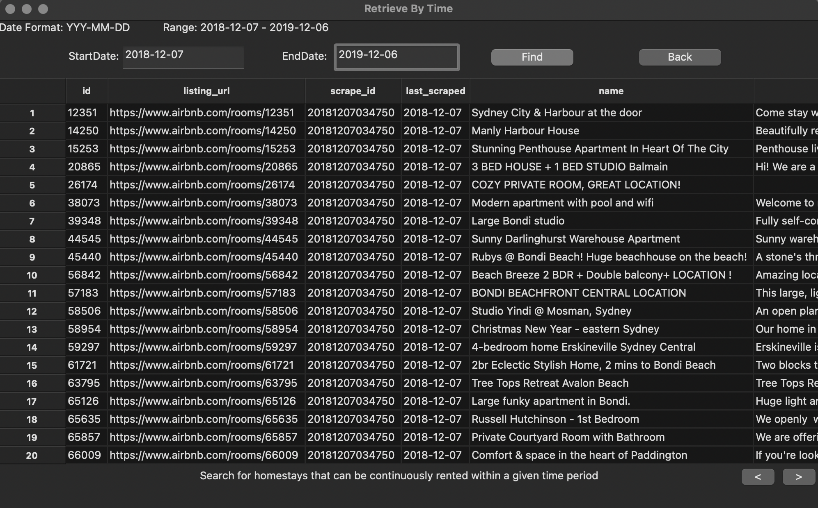

# **Analysis 2 Distribution of price of all listing properties**

The picture indicates the price of property by selected street name from 07/12/2018 to 06/12/2019. In this function, "Housing price trend" feature, generates average property price of different streets by bar chart. It effectively displays the types of property and its price trend within selected time frame. Users are able to see property price trend of street, then decide to choose economy accommodation.

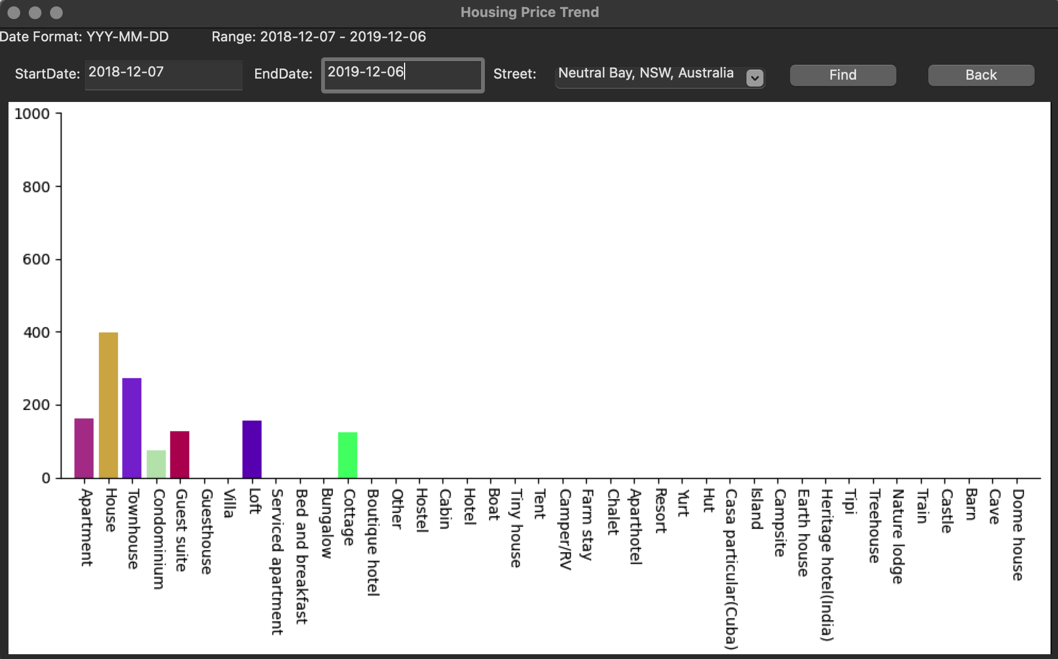

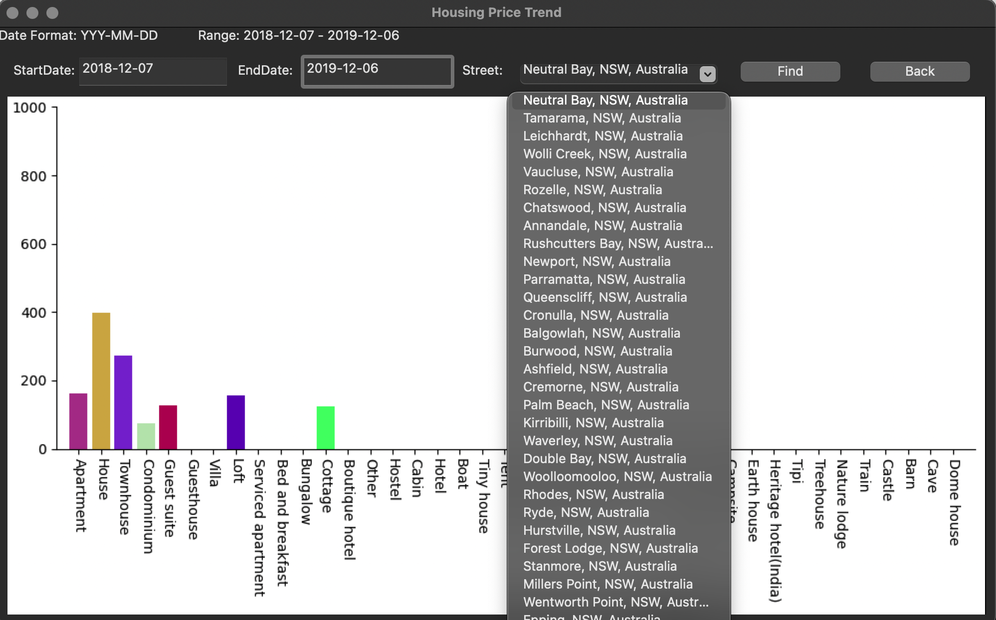

# **Analysis 3 Retrieve all records that search by keywords**

In this function, users can search keyword which retrieve relative record within selected time-period. For instance, if user put one word “sunny”, the result shows record that contains ”sunny” keyword. It helps users quickly locate and retrieve relevant information. Simple phrase (ex. Great location) is acceptable as well.

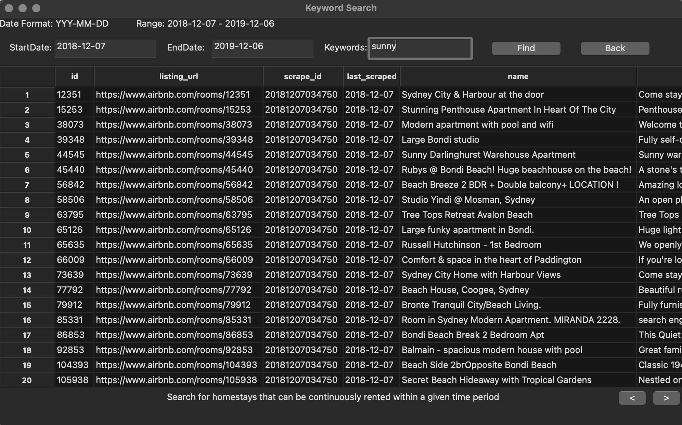

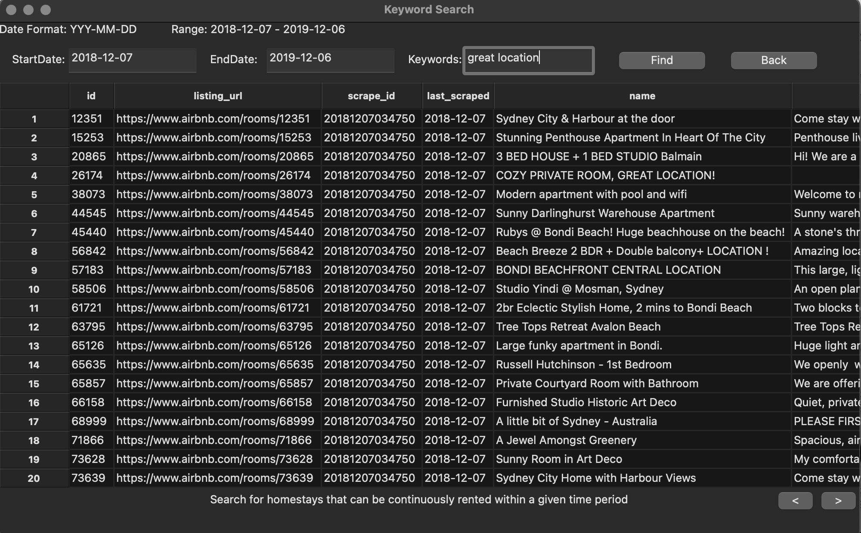

# **Analysis 4 Analyse cleanliness based on the number of reviewers**

In this function, user can easily review cleanliness of each type of property. It is analyzed based on customers’ feedbacks and reviews on Sydney Airbnb. The chart displays how many people that mention specific keyword, which is relevant to cleanliness.

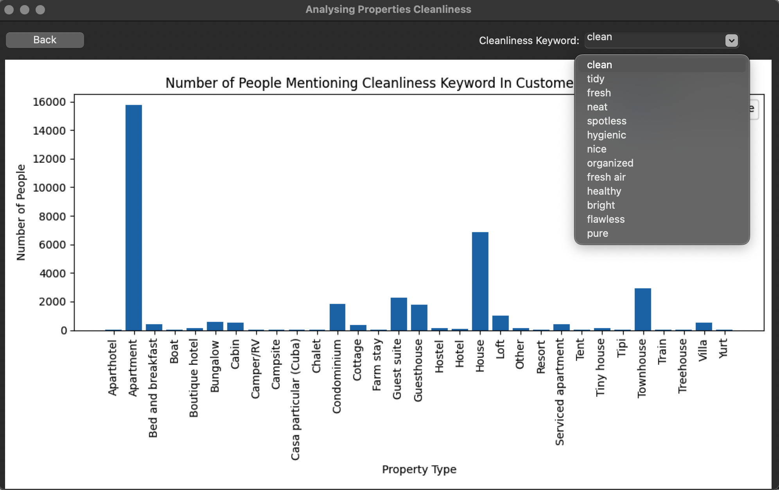

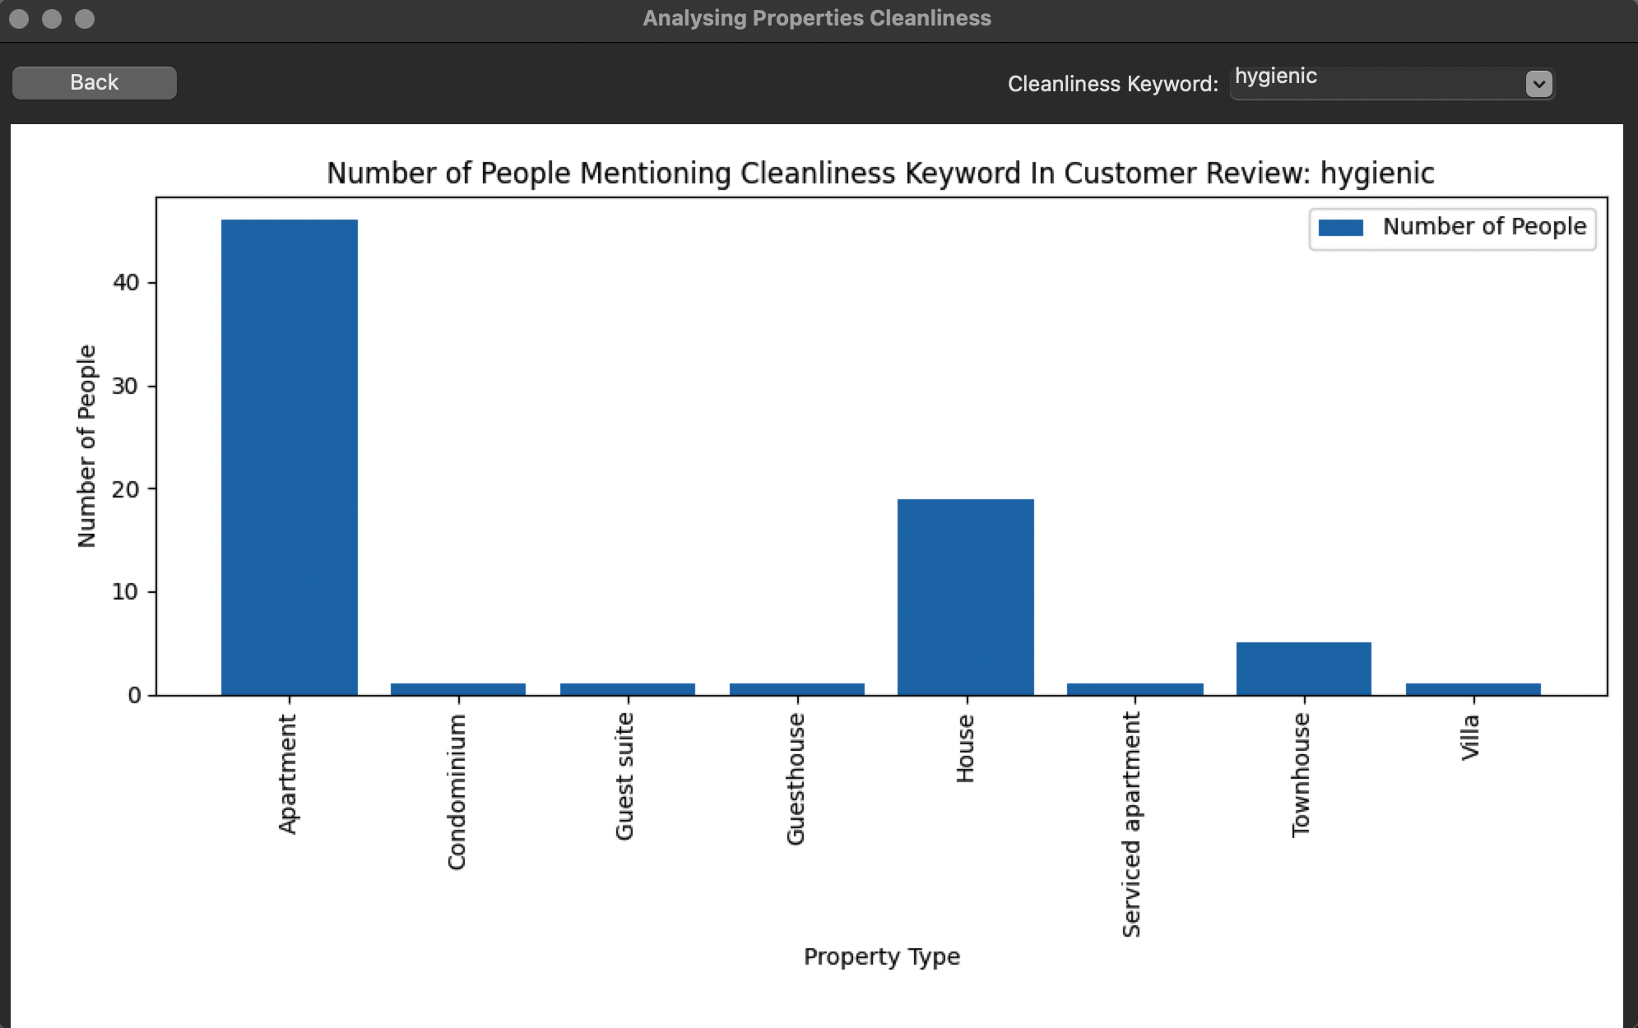

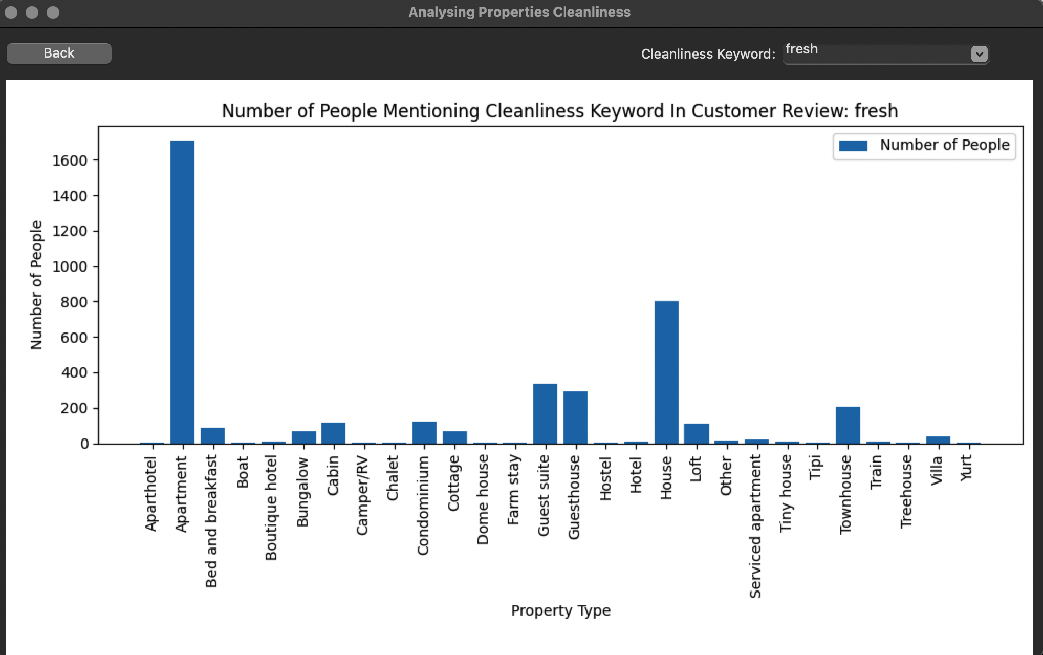

# **Analysis 5 Display rating of properties**

In this function, users can review the rating of each property with its score rating. It is also provided the accuracy of review scores in range 10 and displays total number of review towards each property.

